**INTERNSHIP TITLE**

**AN INTERNSHIP REPORT**

***Submitted by***

**Abhinav Chopra [Reg No: RA1811003010312]**

*Under the guidance of*

**Ms.G. Malarselvi**

(Assistant Professor, Department of Computing Technologies)

***in partial fulfilment for the award of the degree***

***of***

**BACHELOR OF TECHNOLOGY**

in

**COMPUTER SCIENCE AND ENGINEERING**

of

**FACULTY OF ENGINEERING AND TECHNOLOGY**



S.R.M. Nagar, Kattankulathur, Kancheepuram District

**MAY 2022**

**SRM INSTITUTE OF SCIENCE AND TECHNOLOGY**

(Under Section 3 of UGC Act, 1956)

**BONAFIDE CERTIFICATE**

Certified that 18CSP110L internship report titled “**INTERNSHIP TITLE**” is the bonafide work of “**Abhinav Chopra [Reg No:**

**RA1811003010312]**”, who carried out the internship work under my supervision along with the company mentor. Certified further, that to the best of my knowledge the work reported herein does not form any other internship report or dissertation on the basis of which a degree or award was conferred on an earlier occasion on this or any other candidate.

**GUIDE PANEL HEAD**

Ms. G. Malarselvi Dr. Subalalitha C. N

Assistant Professor Associate Porfessor

Dept. of Computing Technologies Dept. of Computing Technologies

**CO-GUIDE**(if any) **HEAD OF THE DEPARTMENT**

Name of the Co-guide Dr. M. Pushpalatha

designation Professor

Dept. of ——– Dept. of Computing Technologies

**INTERNAL EXAMINER EXTERNAL EXAMINER**



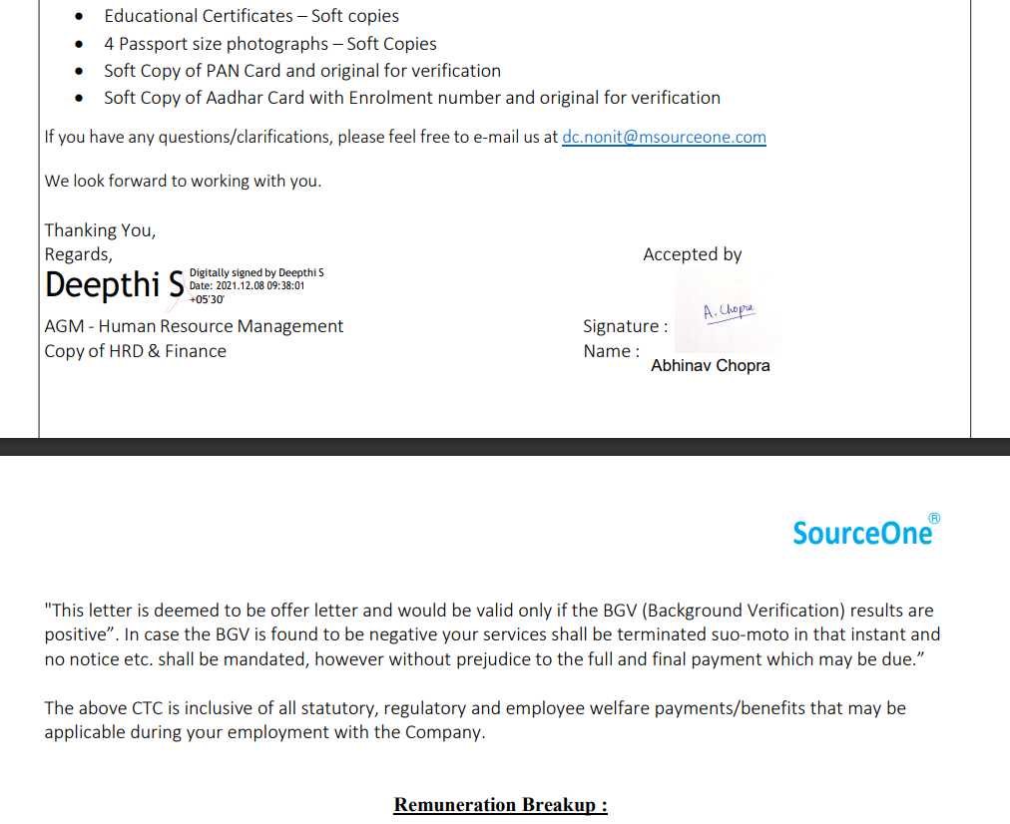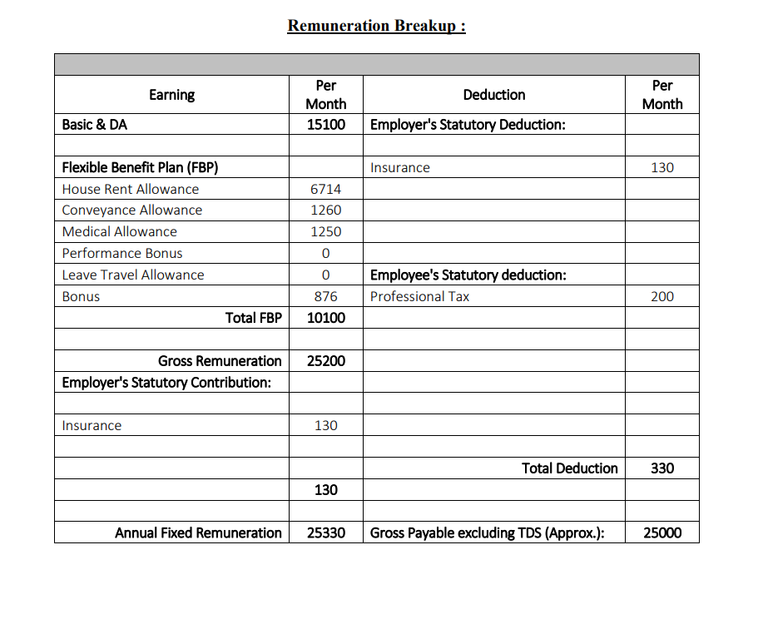

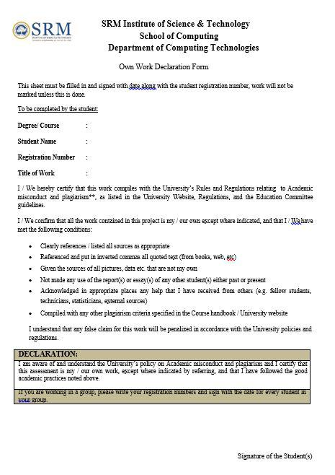

iv

**ACKNOWLEDGEMENTS**

I express our humble gratitude to **Dr.C. Muthamizhchelvan**, Vice Chancellor, SRM Institute of Science and Technology, for the facilities extended for the internship work through on campus placement and his continued support. We extend our sincere thanks to **Dr. Revathi Venkataraman**, Professor & Chairperson, School of Computing, SRM Institute of Science and Technology, for her invaluable support. We wish to thank **Dr. M. Pushpalatha**, Professor & Head, Department of Computing Technologies, SRM Institute of Science and Technology, for her valuable suggestions and encouragement throughout the period of the internship work.

I am extremely grateful to our Panel Head, **Dr. Subalalitha C. N**, Associate Professor, Department of Computing Technologies, SRM Institute of Science and Technology, for her inputs during the monthly reviews. We register our immeasurable thanks to our Faculty Advisor, **Dr. M.S. Abirami**, Associate Professor, Department of Computing Technologies, SRM Institute of Science and Technology, for leading and helping us to complete our course.

Our inexpressible respect and thanks to my guide, **Ms. G. Malarselvi**, Assistant Professor, Department of Computing Technologies, and **Abilash Balasubramanian**, Solution Delivery Manager, Deloitte for providing me an opportunity to pursue my internship under his mentorship. He provided me the freedom and support to explore the work of my interest.

I sincerely thank staff and students of the Computing Technologies Department, SRM Institute of Science and Technology, for their help during my internship work. Finally, we would like to thank my parents, our family members and our friends for their unconditional love, constant support and encouragement.

**Abhinav Chopra**

v

**ABSTRACT**

This report describes my internship at Deloitte. Deloitte is the Biggest of the Big Four accounting firms across the world. With over 334,800 experts worldwide, it provides audit, consultancy, financial advisory, risk advisory, tax, and legal services. The scope of this document is to describe in detail about the things learnt and experience gained during the four months of the internship. Throughout my internship, I attended numerous bootcamps and was exposed to a variety of new technologies, concepts, and frameworks.

TABLE OF CONTENTS

|  |  |  |  |
| --- | --- | --- | --- |
| ACKNOWLEDGEMENTS | | | v |
| ABSTRACT | | | vi |
| LIST OF TABLES | | | ix |
| LIST OF FIGURES | | | x |
| ABBREVIATIONS | | | xi |
| 1 | INTRODUCTION | | 1 |
|  | 1.1 | Company Background . . . . . . . . . . . . . . . . . . . . . . . . | 1 |
|  | 1.2 | Work Responsibilities . . . . . . . . . . . . . . . . . . . . . . . . . | 2 |
|  | 1.3 | Subtitle3 . . . . . . . . . . . . . . . . . . . . . . . . . . . . . . . . | 2 |
| 2 | TECHNOLOGIES | | 3 |
|  | 2.1 | Subtitle1 . . . . . . . . . . . . . . . . . . . . . . . . . . . . . . . . | 3 |
|  | 2.2 | Subtitle2 . . . . . . . . . . . . . . . . . . . . . . . . . . . . . . . . | 3 |
| 3 SYSTEM ARCHITECTURE AND DESIGN | | | 4 |
|  | 3.1 | Subtitle1 . . . . . . . . . . . . . . . . . . . . . . . . . . . . . . . . | 4 |
|  | 3.2 | Subtitle2 . . . . . . . . . . . . . . . . . . . . . . . . . . . . . . . . | 4 |
|  |  | 3.2.1 Sub-sub-title1 . . . . . . . . . . . . . . . . . . . . . . . . . | 4 |
|  |  | 3.2.2 Sub-sub-title2 . . . . . . . . . . . . . . . . . . . . . . . . . | 5 |
| 4 | CONTRIBUTIONS | | 6 |
|  | 4.1 | Subtitle1 . . . . . . . . . . . . . . . . . . . . . . . . . . . . . . . . | 6 |
|  |  | 4.1.1 Sub-sub-title1 . . . . . . . . . . . . . . . . . . . . . . . . . | 6 |
|  |  | 4.1.2 Sub-sub-title2 . . . . . . . . . . . . . . . . . . . . . . . . . | 6 |

vii

|  |  |  |
| --- | --- | --- |
| 5 LEARNING SKILLS AND EXPERIENCES | | 7 |
| 5.1 | Subtitle1 . . . . . . . . . . . . . . . . . . . . . . . . . . . . . . . . | 7 |
| 5.2 | Subtitle2 . . . . . . . . . . . . . . . . . . . . . . . . . . . . . . . . | 7 |
| 5.3 | Subtitle1 . . . . . . . . . . . . . . . . . . . . . . . . . . . . . . . . | 7 |
|  | 5.3.1 Sub-sub-title1 . . . . . . . . . . . . . . . . . . . . . . . . . | 7 |
|  | 5.3.2 sub-sub-title2 . . . . . . . . . . . . . . . . . . . . . . . . . | 7 |
| 5.4 | subtitle2 . . . . . . . . . . . . . . . . . . . . . . . . . . . . . . . . | 7 |
| 6 CONCLUSION | | 9 |
| REFERENCES ............................... | | 10 |
| APPENDIX1TITLEOFTHEAPPENDIX . . . . . . . . . . . . . . . . | | 11 |

LIST OF TABLES

|  |  |
| --- | --- |
| 5.1 Description of the table . . . . . . . . . . . . . . . . . . . . . . . . | 8 |

ix

LIST OF FIGURES

|  |  |
| --- | --- |
| 1.1 American Sign Language . . . . . . . . . . . . . . . . . . . . . . | 1 |

# CHAPTER-1: INTRODUCTION

## About Deloitte

* + 1. **About the Organization**

Deloitte also known as Deloitte Touche Tohmatsu Limited is a multinational professional services company as it has its office locations in over 150 countries around the world and as such its origin was in 1845 with its founder as William Welch Deloitte in London and in 1890 it moved to the United States. With its merge with Haskins & Sells and Touche Ross it came to its full name, with later it being shortened to just Deloitte. It went on further and merged with Arthur Andersen’s in 2002 and Monitor Group in 2013 as it grew up to be a UK private company limited by its guarantee with a top tier network of independent legal entities as its support.

For FY 2021, it earned a whooping revenue of 50.2 billion US dollars in aggregate. It also provides services such as audit, risk advisory, consulting, financial advisory and tax and legal services. It is third largest privately owned company in the US, as of 2020 according to Forbes. Events such as 2012 Summer Olympics have been sponsored by this company.

* + 1. **Main Services provided by Deloitte**

Deloitte member firms offer services in the following functions, with country-specific variations on their legal implementation:

* AUDIT:

With audit as a service the organization provides traditional accounting and audit services as well as Media & Advertising Assurance, IT Control assurance and internal auditing.

* CONSULTING:

This service provides assistance to clients by guiding and helping them in the areas pertaining to Analytics and M&A, Core Business Operations, Human Capital, Strategy, Customer and Marketing, and Enterprise Technology and Performance. Bringing over 40% of the toral revenue in the year 2021, Consulting is Deloitte’s largest business.

* FINANCIAL ADVISORY:

It provides corporate finance services to its clients which include forensics, document review, advisory, dispute, mergers & acquisitions, e-discovery and personal and commercial bankruptcy.

* RISK ADVISORY:

Risk advisory provides services in data quality and integrity, regulatory risk, project risk and cyber risk, enterprise risk management and information security and privacy.

* TAX AND LEGAL:

With tax and legal as it’s service it assists its clients help increase their net asset value, minimize their tax liabilities, implement tax computer systems as well as undertake transfer pricing and tax activities of multiple multinational companies.

* GOVLAB:

With the focus on innovation and government reform, it has it s own internal think tank by the name of GovLab based at New York University in New York created in 2010 as it studies 8 to 9 research topics per year focusing on different future business models, technologies and trends that will affect government.

* + 1. **Risk and Financial Advisory at Deloitte**

Risk and Financial Advisory here in Deloitte helps leading and rising government agencies and enterprises around the world lead in their respective global marketplaces as it helps navigate various risk and opportunities and disrupt the status quo as it encourages them to accelerate performance and embrace the complexity as they reach new heights.

We evolve with the world as we work with our clients as they become the catalysts for change with profound ways and changes underway in technology and business models. With this, our dynamics influence the world around us including the society, commerce and the future. The work that this entails can be classified into the different sub categories depending on the market:

* Internal Audit & Assurance: We help do the internal audit for our clients as we help improve and risk proof the value, importance and transparency of the information they give to the market about their organization and tech performance.
* Cyber Risk: We help boost client security to expect and deter cyber threats. An understanding of their system security can be penetrated is presented to them so that they can upgrade it and protect their information more securely. We also implement strategies to reduce damage and rebound from attacks quickly.
* Financial Risk, Transactions & Restructuring: With financial and structural decisions at hand we inform our clients and deliver insight to help them in their times of transformation or financial crisis.
* Forensic: Gathering and analyzing data to find patterns to discover hidden frauds, corruption and bribery and helping in litigation as well such as purchase price disputes.
* Strategic & Reputation Risk Management: Through our help we enable their senior executives to respond to very real risks which if not taken seriously could undermine their position and jeopardize their brand name.
* Regulatory & Operational Risk: We advise clients on how to manage risks which are associated with their operations, volatility, business relationships and corporate actions.

## About the Internship

This internship was scheduled for 4 months i.e., from 10th Jan,2022 till 29th April,2022., I went through IAM bootcamp, Okta bootcamp, Java bootcamp and ServiceNow and Casl Trainings. Brief description of the topics covered under these bootcamps are mentioned below.

**CHAPTER-2: DEEP DIVE INTO BOOTCAMPS**

* 1. **IAM Bootcamp**
     1. **IAM**
        1. **Definition of IAM**

IAM (Identity and access management) is the frameworks and policies that help enable the right individuals access the exact information they require at the right time for all the relevant and good reasons. To address the very critical, need to allocate the appropriate access to various resources across increasingly variant technology environments as well as to meet the compliance requirement as well we have to use IAM. This has become increasingly business aligned as not only does it require technical expertise but business skill and acumen as well.

And as such those businesses which develop IAM capabilities reduce their identity management costs and become more vigorous in going towards new business initiatives.

* + - 1. **Important Terminologies in IAM**
* Digital Identity/Identity​: It refers to the digital representation of a user, including a unique identifier, credentials and other attributes that makes the complete virtual entity of the user.
* Authentication (AuthN)​: It is the process of validating who the user is claiming to be.
* Authorization (AuthZ)​: It is the process of granting the right access of application and resource to the right person at right time.
* Provisioning​: Complete management of creation of user accounts in information technology (IT) resources and providing appropriate access to those accounts is known as provisioning in IAM.​
* Self-service​: Allowing the end user to perform specific activities without any help and intervention of helpdesk.​
* SSO: SSO stands for Single Sign On. In SSO, user when signs into one account can get access to all other apps under that organization. Using SSO, there is no need to remember different passwords for different apps. Also, it provides better security.
* Connector/Adapter​: Technology used by IAM System to interface and interact with managed systems.
* IT Resource/System​: Application, system, platform for which access is required to perform a specific function. IAM integrates with these IT resources for user account management.
  + - 1. **Key Benefits of IAM**
* Improved User Experience:

IAM helps IT admins create a unique digital identity for each of its user including a set of credentials thereby eliminating the time-consuming task of managing dozens of accounts for various applications. With IAM, end users can access the application anywhere and anytime with any device provided that they are allowed to use it.

* Reduces Password Issues:

Instead of having password related issues such as having too many passwords or forgetting credentials, IAM grants us password management features that help secure it with frequent updates, strong authentication practices such as MFA and biometrics.

* Enhanced Security:

It implements security policies across all the platforms to identify security violations and remove privileges and revoke access whenever it is required. With this employee can access the information and system regarding their specific role and cannot access confidential stuff without approval or getting their permission to a higher level thus preventing insider security threats.

* Improved Efficiency of Security Teams:

This improves the efficiency and effectiveness of the systems by granting access rights, so that their employees and contractors can be efficiently organized with the right access. IAM also helps in managing identities, authentication and the final authorization.

* Improved Regulatory Compliance:

IAM helps organizations meet regulatory compliance and follow government data regulations such as HIPAA, GDPR and CCPA so that they keep customer and employee data safe.

* Reduced IT Operating Costs:

It helps reduce the costs pertaining to account related issues thereby saving an enterprise money which can be well spent on another fruitful endeavor.

* + - 1. **Common IAM methods**
* Single sign-on: A single and unique sign on credentials with which we can access any network, service, application or system required for our work.
* Multi-Factor Authentication: This includes a one set of login credentials needed to access an application in combination with a biometric tool, pin or call/ text-based authentication that helps secure your account.
* Privileged Access Management (PAM): In this procedure, a user has a set of privileges which is considered secure providing more visibility, access control and monitoring.
  + 1. **Identity Lifecycle Management**
       1. **Definition of ILM**

ILM (also known as Identity Lifecycle Management) is the process where we manage the identities of the users and their evolving access privileges throughout the tenure, they are with the Organization from day one to the end and separation. ILM helps automate and simplify the process with onboarding as well as offboarding user and thus forms a crucial element of identity security as it helps in assigning and managing rights with monitoring their track activity as well.

* + - 1. **Importance of ILM**

Some organizations still use manual and inefficient process to provide access to users and grant them privileges which might take days or even weeks before they can do their jobs effectively. While some companies have no automated process to decommission old users, thereby opening them to risk and threats as their confidential data can be stolen.

ILM prevents all this as it helps improve productivity of an employee by giving them access from the day one for their applications. They also eliminate old accounts and privilege creeps to keep the companies’ data protected so that it can focus on more important tasks. With proper service portals, this lets the users request the access rights and also helps them update their account information without hassle or any help desk intervention.

Centralized monitoring and reporting capabilities are provided to help security track activity, investigate incidents as well support audits to maintain and improve the company accounts and data access.

* + - 1. **Stages of ILM**

Identity lifecycle management best practices encompass several stages in the life of an identity.

**Role based access control**​

User is provided access to different system based on the preconfigured business rules.

**Creation**​

ess

**User Identity Creation**​

User Identity is created in the system as per the business process.​

**Creation**​

ess

**Identity Lifecycle Management**

**User Identity Maintenance and audit**​

User Maintenance:​It includes User data modification, Additional role requests, Password reset​, Challenge/Response questions​ etc.

Audit: It includes User Access Review​, Logging and reporting (it includes approver actions, administrator actions).

**Creation**​

**Termination**

It includes removing user access permissions from all tools /applications. It also includes archiving user identity from the system.

* + 1. **Role based Access Control**

USER

ROLE

RIGHTS

* + - 1. **Definition of RBAC**

In RBAC, users are assigned some role and accordingly some access and rights to the resources which are associated with that role are mapped to the users. So, in RBAC,

1. Firstly, user is authenticated.
2. After authentication, users then can activate one or more roles.
3. Based on the roles, users are given access and rights to the resources and application
   * + 1. **Benefits of RBAC**

* Policy needs not to be updated if the person leaves the organization since users are assigned to roles and not directly given access and rights to the resources.
* New employee can easily get access to the resources based on his role.
* Revisiting least privilege because user in one role has access only to the subset of the files and he has to switch his role in order to access other resources.
  1. **Okta Bootcamp**
     1. **Intro to Okta**

To connect any person with any application on any device we use Okta. Its an identity management service, used for enterprises built for the cloud and which is compatible with many applications. It also helps IT admins grant and manage access that a person has to any device or application. Okta integrates deeply with several on-premises applications, identity management systems and directories as it runs in the cloud on a secure and audited platform. With the growing diversity of devices, security issues, mobility and identity issue an Okta solution was born to help resolve it and improve the efficiency of various organizations.

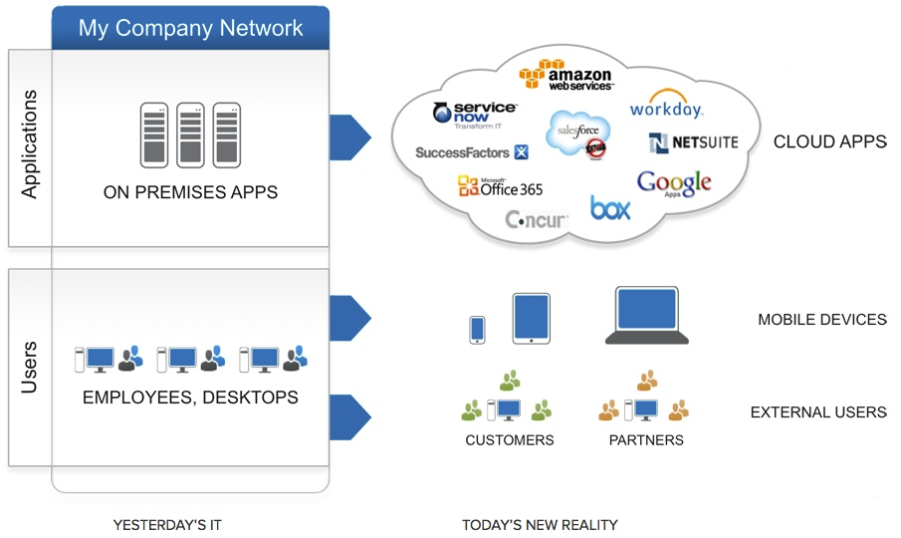

The various features that Okta provides are SSO, MFA, Active Directory, LDAP Integration, Provisioning as well as flexible policies and procedures for organization security and control. And as such a network of pre-integrated applications called as Okta Integration Network (OIN) brings together all of the above functions.

* + 1. **Concept of SSO**

SSO stands for Single Sign On. With its help, when a user signs into one account, he can get access to all the other applications which are under that organization. Its benefits include, no need to remember different passwords for different apps as a single set of credentials helps get access and it also provides better security.

* + 1. **Concept of MFA**

In SSO, if a hacker gets to know our credentials, then he can access everything therefore MFA is needed, as it involves several layers of authentication process which are used to maintain strong security.

Levels in MFA:

* LEVEL-1: This includes *Something you know* i.e., password. But anyone can get to know about password, so another level of authentication is added.
* LEVEL-2: This includes *Something you have* i.e., hardware tokens, authenticators, smart cards etc.
* LEVEL-3: This includes *Something you are* i.e., biometric, retina scan, face recognition etc.
  + 1. **Lab Activities**

# CHAPTER-3: JAVA TRAINING

## Java Concepts Overview

### **Java Basics**

Java is a class-based, object-oriented programming language and is designed to have as few implementation dependencies as possible.

Some important terminologies in context with java are:

* Object − Objects have states and behaviors. Example: A dog has states - color, name, breed as well as behavior such as wagging their tail, barking, eating. An object is an instance of a class.
* Class − A class can be defined as a blueprint that describes the behavior/state that the object of its type supports.
* Methods − A method is basically a behavior. A class can contain many methods. It is in methods where the logics are written, data is manipulated, and all the actions are executed.
* Instance Variables − Each object has its unique set of instance variables. An object's state is created by the values assigned to these instance variables.

### **JDBC**

Database

JDBC

Java Application

### **Servlets**

Servlet can be described as:

* Servlet is a technology which is used to create a web application.
* Servlet is an API that provides many interfaces and classes including documentation.
* Servlet is a class that extends the capabilities of the servers and responds to the incoming requests. It can respond to any requests.
* Servlet is a web component that is deployed on the server to create a dynamic web page.

### **JSP**

**JSP** technology is used to create web application just like Servlet technology. It can be thought of as an extension to Servlet because it provides more functionality than servlet such as expression language, JSTL, etc.

A JSP page consists of HTML tags and JSP tags. The JSP pages are easier to maintain than Servlet because we can separate designing and development. It provides some additional features such as Expression Language, Custom Tags, etc.

### **Hibernate**

Hibernate is a high-performance Object/Relational persistence and query service, which is licensed under the open-source GNU Lesser General Public License (LGPL) and is free to download. Hibernate not only takes care of the mapping from Java classes to database tables (and from Java data types to SQL data types), but also provides data query and retrieval facilities.

### **Derby Database**

Apache Derby is a relational database management system developed by the Apache Software Foundation that can be embedded in Java programs and used for online transaction processing.

### **Tomcat Server**

It is an open-source Java servlet container that implements many Java Enterprise Specs such as the Websites API, Java-Server Pages and finally, the Java Servlet.

### **Spring and Spring Boot**

* **Spring:** Spring Framework is the most popular application development framework of Java. The main feature of the Spring Framework is **dependency Injection**or**Inversion of Control** (IoC). With the help of Spring Framework, we can develop a **loosely** coupled application. It is better to use if application type or characteristics are purely defined.
* **Spring Boot:** Spring Boot is a module of Spring Framework. It allows us to build a stand-alone application with minimal or zero configurations. It is better to use if we want to develop a simple Spring-based application or RESTful services.

### **MVC Model**

The **Model-View-Controller (MVC)** is an architectural pattern that separates an application into three main logical components: the model, the view, and the controller. Each of these components are built to handle specific development aspects of an application. MVC is one of the most frequently used industry-standard web development frameworks to create scalable and extensible projects.

* + **Components of MVC Model**

Following are the components of MVC –

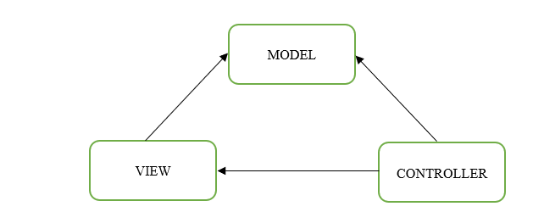

Figure 7: MVC model

* Model:

The Model component corresponds to all the data-related logic that the user works with. This can represent either the data that is being transferred between the View and Controller components or any other business logic-related data. For example, a Customer object will retrieve the customer information from the database, manipulate it and update it data back to the database or use it to render data.

* View:

The View component is used for all the UI logic of the application. For example, the Customer view will include all the UI components such as text boxes, dropdowns, etc. that the final user interacts with.

* Controller:

Controllers act as an interface between Model and View components to process all the business logic and incoming requests, manipulate data using the Model component and interact with the Views to render the final output. For example, the Customer controller will handle all the interactions and inputs from the Customer View and update the database using the Customer Model. The same controller will be used to view the Customer data.

* + 1. **React**

React.js is an open-source JavaScript library that is used for building user interfaces specifically for single-page applications. It has a single HTML page.

DOM stands for ‘Document Object Model’. In simple terms, it is a structured representation of the HTML elements that are present in a webpage or web-app. DOM represents the entire UI of your application. The DOM is represented as a tree data structure. It contains a node for each UI element present in the web document. It is very useful as it allows web developers to modify content through JavaScript, also it being in structured format helps a lot as we can choose specific targets and all the code becomes much easier to work with.

**CHAPTER 4 Service Now and Casl**

## Service now

## Introduction of Service Now

ServiceNow is mainly used for workflow and process automation as it follows the ITIL principles as it’s a cloud-based platform. It was founded in 2004 by Fred Luddy and is an American based company. I t has various versions and has a unique way of naming them, as they are based on the major cities of the world, with the latest version being Orlando. Many read workflows, solutions and products are offered by ServiceNow for an organization.

* + 1. **Features of Service Now**

## Some of its most widely used services are as follows:

* IT Service Management

It’s used as a ticketing tool to manage tickets, requests, incidents and problems. It also has advanced features that impact the speed of IT.

* HR Management

Its also sued for timesheet, leave, employee document, performance management, etc.

* IT Asset Management

It helps manage our hardware and software to reduce cost and increase efficiency and it also has features such as warranty and license management.

* Finance operation management

It also manages activities related o financial processes .